SOFTWARE TESTING REPORT
Hospital Management System – Patient Registration Module
Module Name: Hospital Management System – Patient Registration Module
Test Case IDs: TC001
Webpage URL: file:///C:/Users/Rudra/Downloads/HBM_ST2_patient_registration_test_demo.html

Scenario ID: TC001
Scenario: Register a patient using valid details
Test Steps:
- 1. Run the program
- 2. Enter patient name
- 3. Enter patient age
- 4. Enter phone number
- 5. Complete registration
Test Input: Name: Rahul
Age: 31
Phone: 8860014423
Expected Result: Patient Registered Successfully.
Actual Result: Patient Registered Successfully.
Status: Pass
Comments: Valid patient details; registration succeeds.
Screenshot:
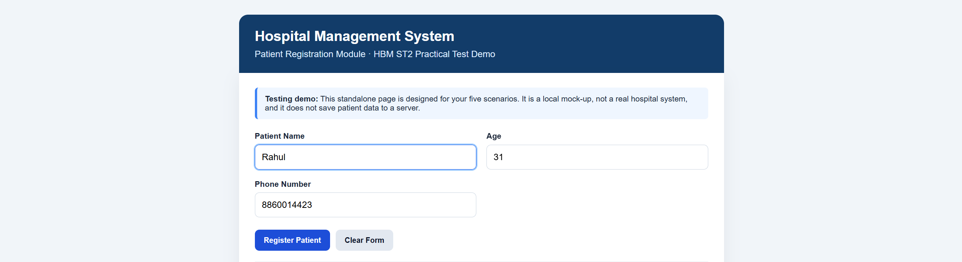
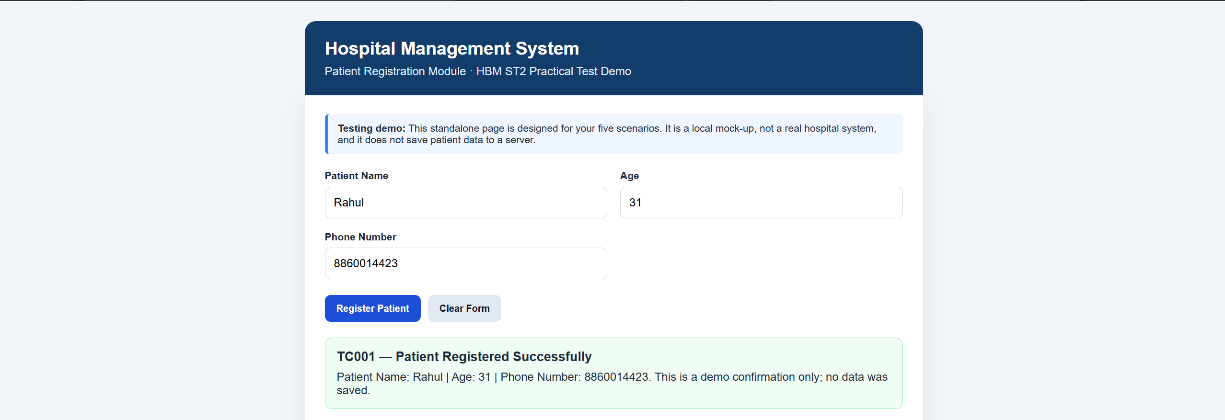
Scenario ID: TC002
Scenario: Register a patient without entering a name
Test Steps:
- 1. Run the program
- 2. Leave patient name blank
- 3. Enter patient age
- 4. Enter phone number
- 5. Submit registration
Test Input: Name: Blank
Age: 31
Phone: 8860014423
Expected Result: Empty name is rejected or a validation message is displayed.
Actual Result: Empty name is accepted; registration completed without name validation.
Status: Fail
Comments: The empty-name validation did not work as expected.
Screenshot:
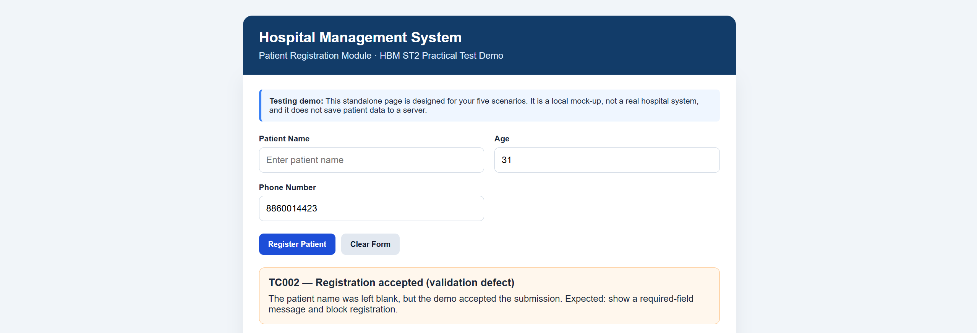

Scenario ID: TC003
Scenario: Register a patient with an invalid age
Test Steps:
- 1. Run the program
- 2. Enter patient name
- 3. Enter age as -5
- 4. Enter phone number
- 5. Submit registration
Test Input: Name: Rahul
Age: -5
Phone: 8860014423
Expected Result: Invalid age is rejected or a validation message is displayed.
Actual Result: Negative age accepted without validation; registration completed.
Status: Fail
Comments: The negative age was not blocked.
Screenshot:
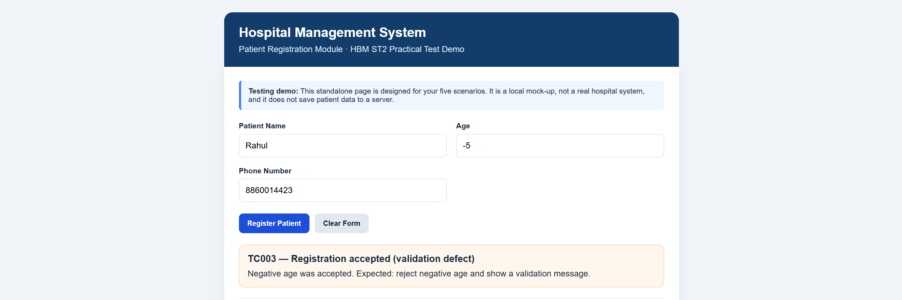

Scenario ID: TC004
Scenario: Register a patient using an invalid phone number
Test Steps:
- 1. Run the program
- 2. Enter patient name
- 3. Enter patient age
- 4. Enter phone number as 123
- 5. Submit registration
Test Input: Name: Rahul
Age: 31
Phone: 123
Expected Result: Invalid phone number is rejected or a validation message is displayed.
Actual Result: Phone number accepted without validation; registration may complete.
Status: Fail
Comments: The short phone number was not validated.
Screenshot:
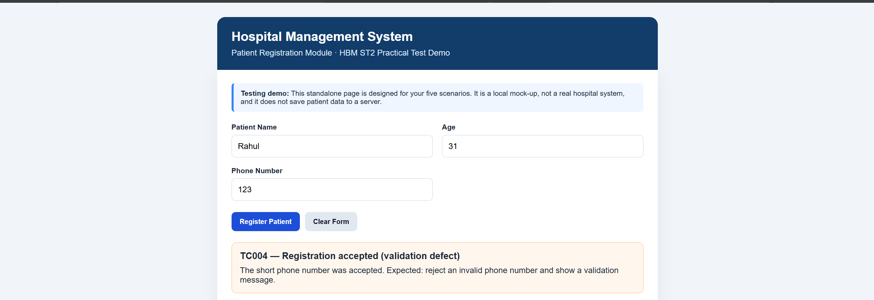

Scenario ID: TC005
Scenario: Register a patient by entering text instead of a numeric age
Test Steps:
- 1. Run the program
- 2. Enter patient name
- 3. Enter age as abc
- 4. Enter phone number if the program continues
- 5. Submit registration if possible
Test Input: Name: Rahul
Age: abc
Phone: 8860014423
Expected Result: Invalid age is rejected or an appropriate error is displayed without an unexpected crash.
Actual Result: Non-numeric age input is validated; program may raise an error or stop.
Status: Pass
Comments: Non-numeric age handling requires validation.
Screenshot:
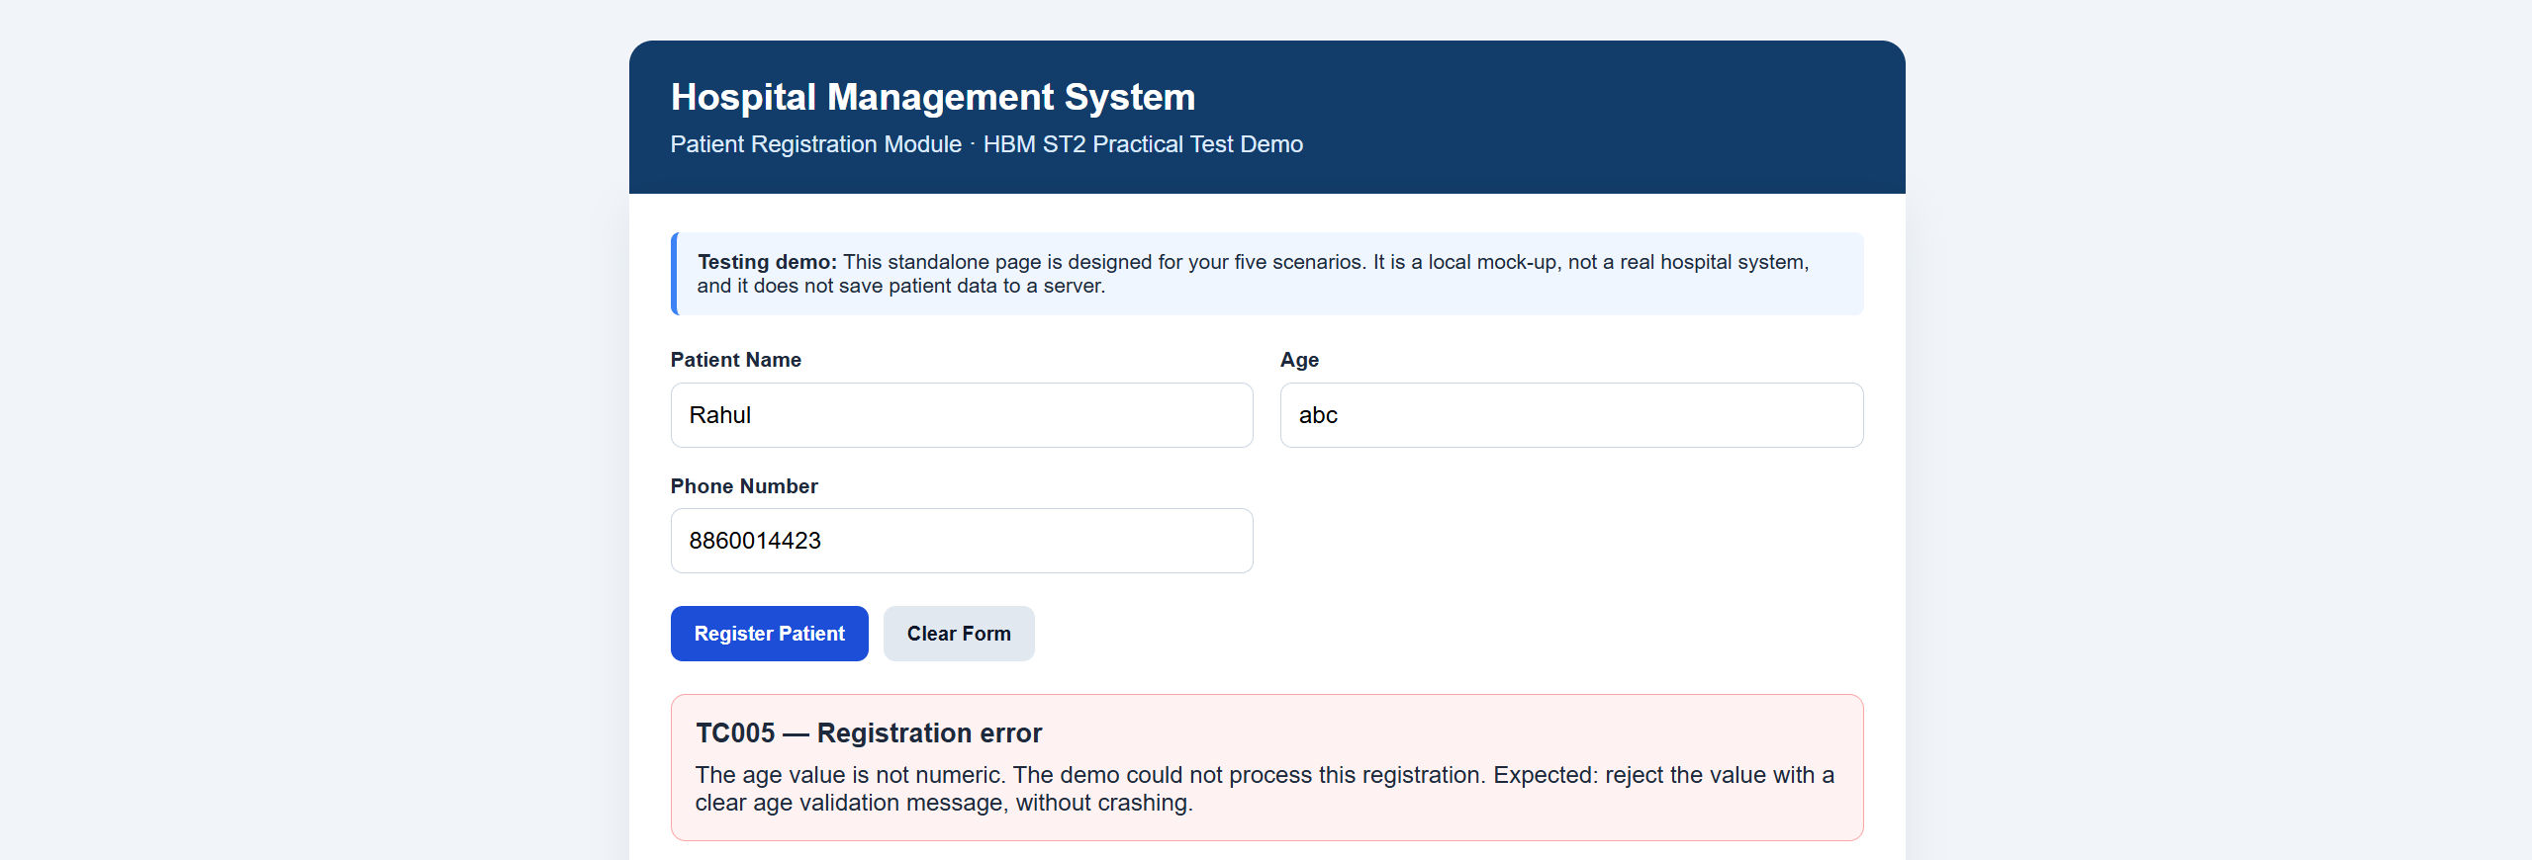

Summary of Test Results
Metric | Result
Total Test Scenarios | 5
Passed | 2
Failed | 3
Pass Percentage | 20%

Conclusion and Recommendations
The report covers five patient-registration test scenarios for the Hospital Management System. The valid-details scenario passed, while the blank-name, negative-age, invalid-phone, and non-numeric-age scenarios require validation improvements. Insert the corresponding screenshots before final submission.
Recommendation: Add input validation for required patient names, acceptable age ranges, phone-number length/format, and numeric age input. Display clear validation messages and prevent registration when the entered data is invalid.

